**P3 Summary Higher**

**Graphs**Distance Time Graphs – flat line means the person is stopped, the gradient indicates the speed

Speed Time Graphs – flat line means the speed is constant, the area under the graph shows the distance travelled and the gradient indicates the acceleration.

**Speed**  
**Speed = Distance  
 time**  
Speed limits depend on the type of road – e.g. slower speed limits in urban areas near schools.

Speed cameras take 2 photos 0.5s apart and measure distance by the white lines on the road. They can then calculate speed of the car.



**Forces**  
**Force = mass x acceleration**

If the forces are balanced, then the object is stationary or moving at a   
constant speed.  
If forces are unbalanced  
then you can work out forward  
force – backward force. If you get a positive number, then the car accelerates.

**Velocity**The speed of a moving object in a certain direction.

Relative Velocity – If 2 trains are moving past each other in opposite directions at 30m/s, to people on train 2 it will seem like train 1 is moving at 60m/s. This is the velocity of train 1 relative to the velocity of train 2.

Accelerating when speed is constant – if a car goes round a roundabout at a constant speed then it is actually accelerating. This is because its direction is changing.

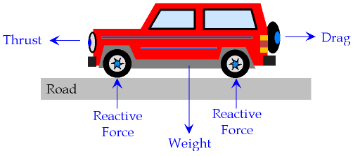

**Road Safety**Stopping Distance = Thinking Distance + Stopping Distance  
Thinking Distance is affected by drugs, alcohol, tiredness, lack of concentration and speed.  
Braking Distance is affected by road   
conditions, worn tyres, worn brakes,   
mass of car and speed.  
When speed doubles, thinking  
distance double. When speed doubles, braking distance quadruples.

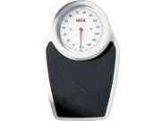

**Work and Weight**Work is done when a force moves.   
**Work Done = Force x Distance Moved**  
When a car brakes and stops it loses all its kinetic energy. Kinetic Energy lost = Work Done by the brakes

Weight is the force of attraction on a mass due to gravity.   
Weight = Mass x 10 (gravitational field strength)



**Power and Fuel  
Power = Work Done  
 time taken**  
Powerful cars (with bigger engines) have a higher fuel consumption, so are expensive to run. Fuel products pollute the environment.  
Also, Power = Force x Speed

**Fuels**Petrol and diesel are **fossil fuels**. These cause pollution such as global warming.  
Some renewable energy sources, such as **biofuels** are being developed.  
**Solar** energy is being considered for cars.  
**Electric** cars are becoming more common – often using batteries, which have to be charged.

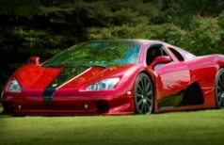

**Kinetic Energy**All moving objects have kinetic energy. If speed doubles, KE quadruples,  
**KE is calculated by = ½ mv2** m = mass, v = speed. braking distance quadruples.  
KE is measured in joules (J).

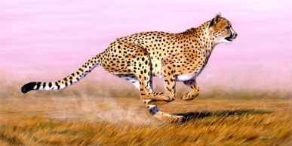

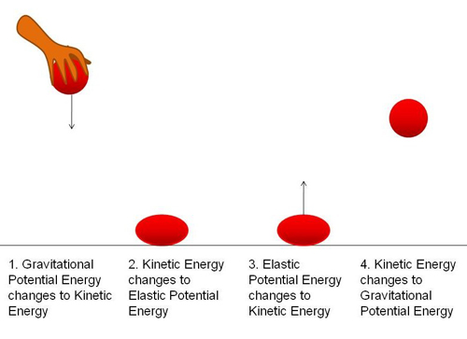**[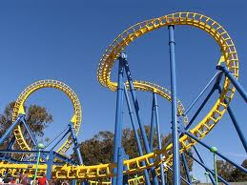](http://www.google.co.uk/imgres?q=rollercoaster&hl=en&biw=1024&bih=571&tbm=isch&tbnid=_iYGmm-H37dJjM:&imgrefurl=http://cepolina.com/roller_coaster_curve_yellow_overall.html&docid=q88a8hlyadXAmM&imgurl=http://www.cepolina.com/photo/technology/funfair/roller_coaster/2/roller_coaster_curve_yellow_overall.jpg&w=640&h=480&ei=AmTrT4-wHITQ-gal4cDnBQ&zoom=1&iact=hc&vpx=278&vpy=242&dur=1890&hovh=194&hovw=259&tx=134&ty=129&sig=116666784730613600908&page=2&tbnh=119&tbnw=159&start=9&ndsp=20&ved=1t:429,r:6,s:9,i:122)**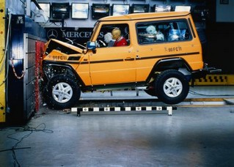

**Gravitational Potential Energy (GPE)**Any object held above the ground has GPE. This varies with the **mass** of the object and the **height** it is held at.

A car on a rollercoaster at the top of a hill has lots of GPE. This converts to kinetic energy as it moves down the hill. Some energy is wasted as sound and heat.

**GPE = mgh**m = mass (kg)  
g = gravitational field strength (10N/kg)  
h = height (m)

**Acceleration Due to Gravity (*g*)**This is the same all over the Earth. It is 10N/kg.  
It is unaffected by changes in the atmosphere. It varies slightly around the poles and changes even more slightly by the height above sea level.

**Falling Objects**Objects fall because of **gravity**. Objects with a bigger surface area have more drag (air resistance) so fall more slowly.  
When air resistance equals weight, the forces are balanced and the falling object reaches **terminal speed**. This is a constant speed.

As a parachutist falls, they displace air molecules, which increases air resistance.

**Safety Features to Prevent Crashes (Primary Safety Features)**1. Anti-lock brakes (maintain steering when braking hard)  
2. Traction control (prevents wheel spin)  
3. Electric windows (limits distraction)

**Safety Features to Protect People (Secondary Safety Features)**1. Crumple zones that absorb energy and increase stopping time  
2. Seatbelts that stretch to slow a person down  
3. Air bags that inflate to absorb a person’s KE  
These features must be crash tested before cars are sold.  
  
  
  
  
4. Controls on the steering wheel (limits distraction)

**Cars**Cars that are streamlined reduce friction, so they can improve their fuel consumption.   
You can do this by:   
1. Shaping car roof boxes  
2. Creating cars in a wedge  
3. Angling lorry deflectors

**Factors Affecting Fuel Consumption**  
1. Amount of energy needed to increase kinetic energy  
2. Shape of the car (working against friction)  
3. Speed and kinetic energy  
4. The way in which it’s driven (acceleration, braking)  
5. Road conditions

**Momentum**Moving cars have momentum.  
**Momentum = mass x velocity**  
In accidents cars stop suddenly, so momentum becomes 0. This rapid change leads to a large force in a crash, risking injuries. You must reduce forces to reduce injuries.  
**Force = Change in momentum  
 time**