GCSE
“We are what we repeatedly do. Excellence, therefore, is not an act but a habit”
Core Gateway Science B
C1: Carbon Chemistry

Unit |  | Page | Completed By
1a | Making Crude Oil Useful | 46
1b | Using Carbon Fuels | 48
1c | Clean Air | 50
1d | Making Polymers | 52
1e | Designer Polymers | 54
1f | Cooking and Food Additives | 56
1g | Smells | 58
1h | Paints and Pigments | 60
Use the activities and past exam questions in this booklet to plan and support your revision ready for the B1C1P1 science exam.
REVISION WEBSITE – The follow website is available for you to use to support you revision and help you answer the exam questions in this revision guide
http://www.bbc.co.uk/schools/gcsebitesize/science/ocr_gateway/
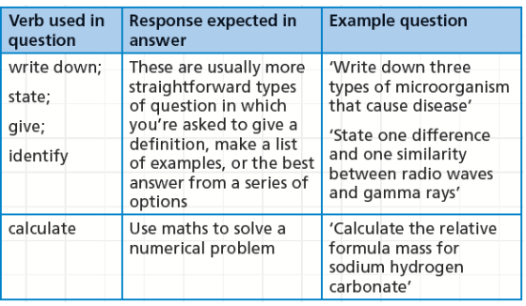
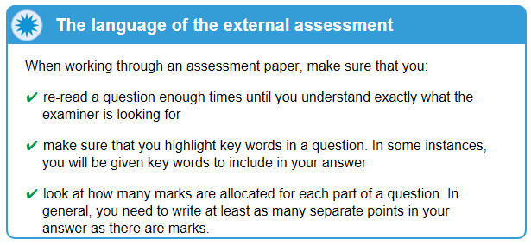
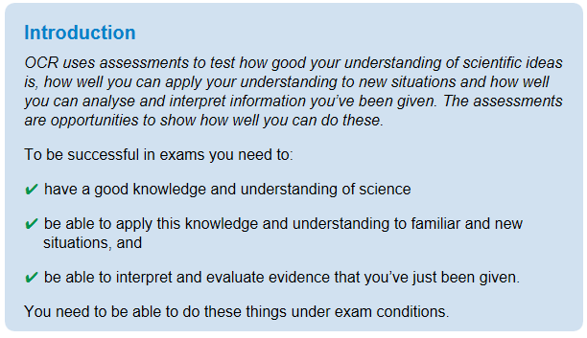
C1a: Making Crude Oil Useful
Grade E Grade C Grade A
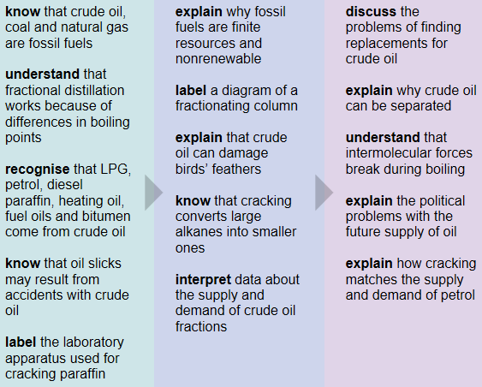
Key Information
Crude oil is a mixture of hydrocarbons. These are separated into useful products, such as fuels, using a process called fractional distillation.

The demand for short hydrocarbon molecules is greater than their supply in crude oil, so a reaction called cracking is used. Cracking converts long alkane molecules into shorter alkanes and alkenes, which are more useful.
Revision Ideas
- Draw and label the apparatus uses for cracking paraffin in the laboratory
- Make a poster about fractional distillation. Label the column showing the different uses of each fraction

QWC Question (6 marks)
When answering a QWC question remember the following points: Use correct science vocabulary, organise ideas, avoid using “it”, and write in full sentences. You also need to try and keep you answer relevant to the question. A good way to do all this is to write out important key vocabulary and then use them to structure your answer. Underlining them will help you keep track and highlight to the examiner your good use of key terms,
Question – This question is about crude oil.
Crude oil is a mixture of different lengths of hydrocarbons called fractions. To make crude oil useful it has to be separated into these fractions. Describe how the process of fractional distillation works and explain how the fractions are separated (6marks)
Important words list
Heated
Gradient
Column
Bitumen
LPG
Diesel
Boiling points
Chain length
Cooled down

C1b: Using Carbon Fuels
Grade E Grade C Grade A
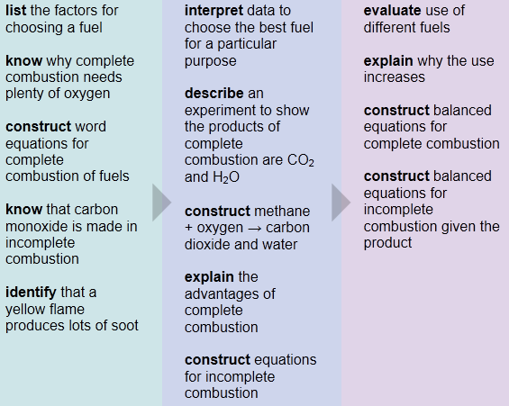
Key Information
Fuels react with oxygen to release energy. Complete combustion happens in a plentiful supply of air and incomplete combustion occurs when the supply of air is limited.

Complete combustion releases more energy than incomplete combustion. Incomplete combustion also creates carbon monoxide, and more soot. Several factors must be considered when choosing the best fuel for a particular purpose
Revision Ideas
- Write out the word equations for complete and incomplete combustion of fuels.
- Chose a fuel for the following purposes and explain what properties make it suitable. Heating a home, cooking food and powering a car.
QWC Question (6 marks)
When answering a QWC question remember the following points: Use correct science vocabulary, organise ideas, avoid using “it”, and write in full sentences. You also need to try and keep you answer relevant to the question. A good way to do all this is to write out important key vocabulary and then use them to structure your answer. Underlining them will help you keep track and highlight to the examiner your good use of key terms,
Question – This question is about choosing a fuel
Donald is choosing a fuel for powering his new canal boat. Explain to Donald what factors he needs to consider when choosing a fuel and suggest what fuels wouldn’t be suitable. (6marks)
Important words list
Energy value
Availability
Ease of storage
Cost
Toxicity
Pollution
Ease of use
Coal
Oil
Wood
C1c: Clean Air
Grade E Grade C Grade A
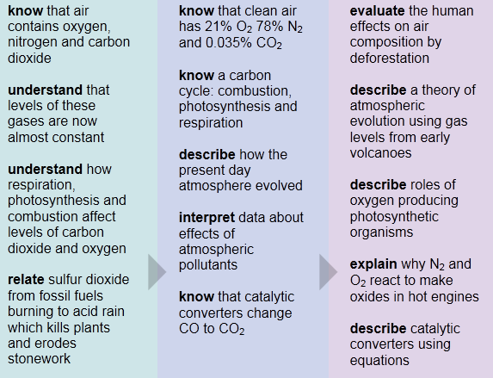
Key Information
The atmosphere consists mainly of nitrogen and oxygen, with smaller proportions of other gases such as carbon dioxide. The amount of carbon dioxide in the atmosphere is maintained through a balance between processes such as photosynthesis, respiration and combustion. But human activities are polluting the atmosphere.

Photosynthesis by plants is thought to be a key process in the evolution of the Earth’s atmosphere.
Revision Ideas
- Draw a diagram of the carbon cycle with a description of the following processes; respiration, combustion and photosynthesis
- Make a card sort on the different types of air pollution and their sources.
QWC Question (6 marks)
When answering a QWC question remember the following points: Use correct science vocabulary, organise ideas, avoid using “it”, and write in full sentences. You also need to try and keep you answer relevant to the question. A good way to do all this is to write out important key vocabulary and then use them to structure your answer. Underlining them will help you keep track and highlight to the examiner your good use of key terms,
Question – This question is the changing levels of gases in our Atmosphere.
The Earth’s atmosphere hasn’t always been the same as today. Describe how the atmosphere has changed over billions of years and explain what has caused these changes. (6marks)
Important words list
Volcanoes
Ammonia
Carbon dioxide
Photosynthesis
Plants
Oxygen
Respiration
C1d: Making Polymers
Grade E Grade C Grade A
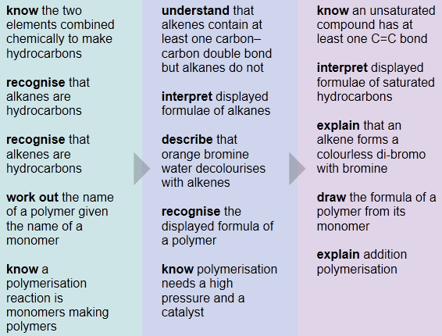
Key Information
Hydrocarbons are compounds made from carbon and hydrogen atoms joined by covalent bonds. Alkanes are saturated - they have only single bonds. Alkenes have a double bond - they are unsaturated. Alkenes react with brown bromine water and decolourise it, but alkanes do not.

Alkenes can act as monomers. Under high pressure and in the presence of a catalyst many monomer molecules join together to make polymer molecules. These polymer molecules are saturated.
Revision Ideas
- Make a card match game using the diagrams of different alkanes and alkenes and their names
- Create a revision card on polymerisation
QWC Question (6 marks)
When answering a QWC question remember the following points: Use correct science vocabulary, organise ideas, avoid using “it”, and write in full sentences. You also need to try and keep you answer relevant to the question. A good way to do all this is to write out important key vocabulary and then use them to structure your answer. Underlining them will help you keep track and highlight to the examiner your good use of key terms,
Question – This question is alkanes and alkenes
Alkenes made by the cracking of alkanes can be made into polymers. Describe the difference between and alkene and alkane, how you can test for alkenes and how alkenes can be joined together to make polymers (6marks)
Important words list
Covalent bond
Single / double
Bromine water
Decolourise
Polymerisation
High pressure
Catalyst
Monomers
Long chain
C1e: Designer Polymers
Grade E Grade C Grade A
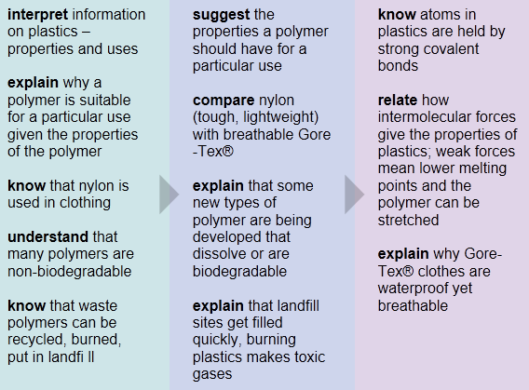
Key Information
A lot of everyday items are made from polymers. Many of these polymers are not biodegradable - microbes cannot digest them and they take a long time to break down. Polymers are usually disposed of by burying them in landfill sites or burning them in incinerators. These methods of disposal cause environmental problems, and waste valuable resources.

The properties of polymers depend on the structure and bonding found in their molecules. Smart materials such as Gore-Tex® have more useful properties than other polymers.
Revision Ideas
- Create a table to show the different properties of polymers and their uses
- Make a poster advertising your new product “Gore-Tex”.
QWC Question (6 marks)
When answering a QWC question remember the following points: Use correct science vocabulary, organise ideas, avoid using “it”, and write in full sentences. You also need to try and keep you answer relevant to the question. A good way to do all this is to write out important key vocabulary and then use them to structure your answer. Underlining them will help you keep track and highlight to the examiner your good use of key terms,
Question – This question is about waste polymers
We produce a large amount of plastic waster (polymers) which can be difficult to dispose of. Discuss the advantages and disadvantages of 3 different disposal methods. (6marks)
Important words list
Landfill Sites
Non-biodegradable
Burning
Air pollution
Toxic Fumes
Valuable resources
Recycling
Cost
Needs sorting
C1f: Cooking and Food Additives
Grade E Grade C Grade A
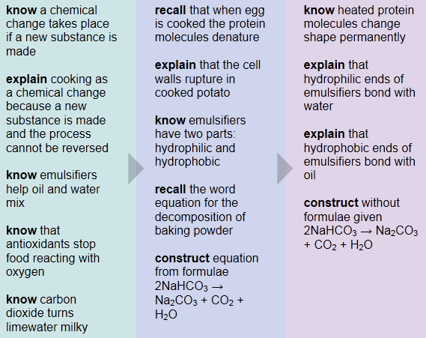
Key Information
Cooking brings about chemical changes in food. The texture and taste changes when food is cooked. Baking powder contains sodium hydrogencarbonate. This breaks down when heated, releasing carbon dioxide that helps cake mixtures to rise during baking.

Food additives are included in food to improve their shelf-life, appearance and flavour. Antioxidants such as ascorbic acid prevent food from going off by reacting with oxygen. Emulsifiers help oil and water to mix - for example, in mayonnaise
Revision Ideas
- Write out the word equation for the decomposition of baking powder.
- Produce a card sort on the different types of food additives and what they do.
QWC Question (6 marks)
When answering a QWC question remember the following points: Use correct science vocabulary, organise ideas, avoid using “it”, and write in full sentences. You also need to try and keep you answer relevant to the question. A good way to do all this is to write out important key vocabulary and then use them to structure your answer. Underlining them will help you keep track and highlight to the examiner your good use of key terms,
Question – This question is about chemical changes during cooking.
A food changes when it is cooked. Cooking is a chemical change. Explain what a chemical change is and describe what happens to proteins (in eggs and meat) when they are cooked. (6marks)
Important words list
Irreversible
Energy change
Chemical changes
Eggs / meat
Proteins
Change shape
Denaturing
Colour
Texture
C1g: Smells
Grade E Grade C Grade A
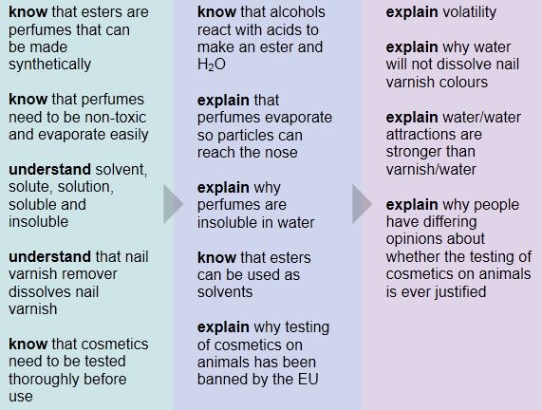
Key Information
Esters are made by reacting an alcohol with an organic acid. They are used in perfumes, and as solvents. Nail varnish dissolves in nail varnish remover, but not in water.
Revision Ideas
- Make a poster advertising a new perfume. Tell the customers about all the properties of the perfume that make it a good perfume
- Make a key word definition list for the following words; pungent, insoluble, soluble, evaporates, ester, volatile, solvent, solute, solution
QWC Question (6 marks)
When answering a QWC question remember the following points: Use correct science vocabulary, organise ideas, avoid using “it”, and write in full sentences. You also need to try and keep you answer relevant to the question. A good way to do all this is to write out important key vocabulary and then use them to structure your answer. Underlining them will help you keep track and highlight to the examiner your good use of key terms,
Question – This question making a perfume
Perfumes can be made from natural sources, whilst others can be made synthetically in a laboratory. Explain how an ester is made and describe three properties of a perfume. (6marks)
Important words list
Ester
Alcohol
Acid
Water
Evaporates
Non-toxic
Irritable
Insoluble
No reaction with water
C1h: Paints and Pigments
Grade E Grade C Grade A
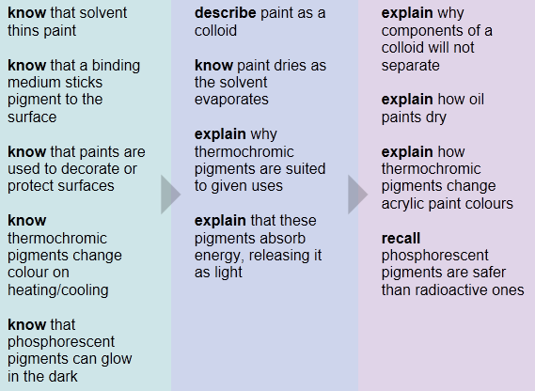
Key Information
Pigments are coloured substances used in paint. Paints are a type of mixture called a colloid. They contain several components, including the pigment, a solvent and a binding medium.

Thermochromic and phosphorescent pigments are very useful, and extend the normal properties of paints.
Revision Ideas
- Draw a diagram to show what happens when oil paints and emulsion paints dry.
- Write an exam question and mark scheme on the different substances in paints.
QWC Question (6 marks)
When answering a QWC question remember the following points: Use correct science vocabulary, organise ideas, avoid using “it”, and write in full sentences. You also need to try and keep you answer relevant to the question. A good way to do all this is to write out important key vocabulary and then use them to structure your answer. Underlining them will help you keep track and highlight to the examiner your good use of key terms,
Question – This question is paints and pigments
Some paints have special properties. Describe what is special about themochromic and phosphorescent pigments and describe some uses for each (6marks)
Important words list
Change colour
Hot / cold
Temperature
Absorb
Light energy
Glow in the dark
Safety
Warning
Bath toys

