GCSE
“We are what we repeatedly do. Excellence, therefore, is not an act but a habit”
Core Gateway Science B
B2: Understanding our environment

Unit |  | Page | Completed By
2a | Classification | 24
2b | Energy Flow | 26
2c | Recycling | 28
2d | Interdependence | 30
2e | Adaptations | 32
2f | Natural Selection | 34
2g | Population and Pollution | 36
2h | Sustainability | 38
Use the activities and past exam questions in this booklet to plan and support your revision ready for the B2C2P2 science exam.
REVISION WEBSITE – The follow website is available for you to use to support you revision and help you answer the exam questions in this revision guide
http://www.bbc.co.uk/schools/gcsebitesize/science/ocr_gateway/
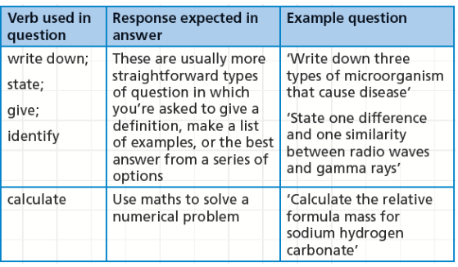
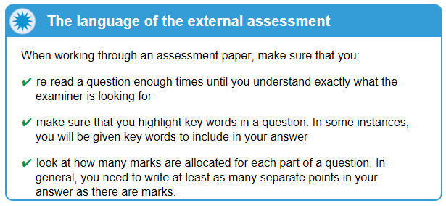
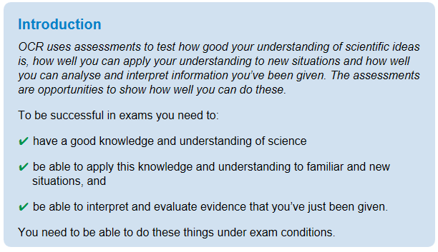
B2a: Classification
Grade E Grade C Grade A
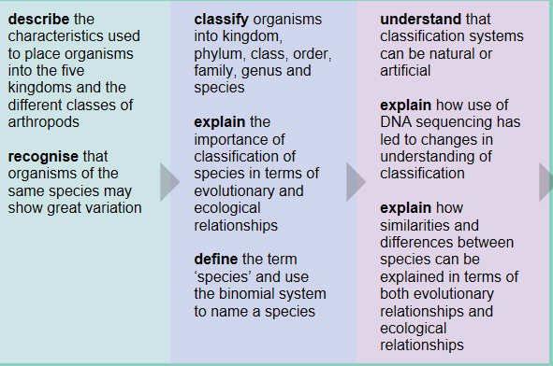
Key Information
Living organisms need to be put into groups so that scientists can study them effectively. The more closely related they are, the closer the groups. The ‘binomial system’ is a way of giving living things scientific names so that scientists with different languages can identify them.
Revision Ideas
- Make some revision cards with facts about the different kingdoms.
- Make up a rhyme to remember the order of the different groups – ‘King Phillip Came Over From Green Spain’ – can you do any better?

QWC Question (6 marks)
When answering a QWC question remember the following points: Use correct science vocabulary, organise ideas, avoid using “it”, and write in full sentences. You also need to try and keep you answer relevant to the question. A good way to do all this is to write out important key vocabulary and then use them to structure your answer. Underlining them will help you keep track and highlight to the examiner your good use of key terms,
Question – This question is about classification.
Living organisms are classified (grouped) according to shared characteristics. The biggest group of living organisms is a kingdom. There are 5 kingdoms – name each one and explain how you would know if an organism was in that kingdom. (6marks)
Important words list
Protoctista
Prokaryotes
Plants, Fungi
Animals, Cell
Nucleus, Wall
Cellulose
Chitin
Chloroplasts
Photosynthesis

B2b: Energy flow
Grade E Grade C Grade A
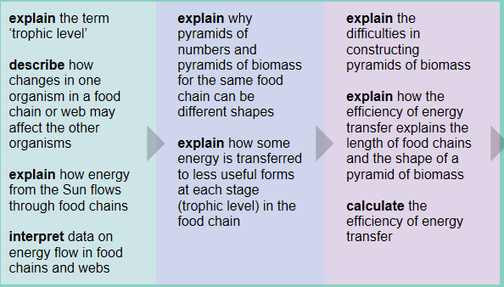
Key Information
Energy flows from the sun to plants, which produce food, and then through food chains. Each level is called a trophic level. Energy is lost at each level in the food chain. Food chains can be shown by pyramids of number or biomass.

Revision Ideas
- Draw a food chain and a pyramid of biomass to go with it. Label the diagrams to show how energy is lost at each level.
- Make a card sort for all the different terms e.g. trophic level, primary consumer, carnivore.

QWC Question (6 marks)
When answering a QWC question remember the following points: Use correct science vocabulary, organise ideas, avoid using “it”, and write in full sentences. You also need to try and keep you answer relevant to the question. A good way to do all this is to write out important key vocabulary and then use them to structure your answer. Underlining them will help you keep track and highlight to the examiner your good use of key terms,
Question – This question is about energy flow.
Food chains show the transfer or energy from organism to organism. Draw a food chain that includes grass, a small bird, a caterpillar and an eagle. Describe the chain using as many scientific terms as you can, and explain how energy is lost at each level. (6marks)
Important words list
Trophic level
Producer
Primary consumer
Herbivore
Secondary consumer
Carnivore
Ingestion
Egestion
Movement
Respiration
B2c: Recycling
Grade E Grade C Grade A
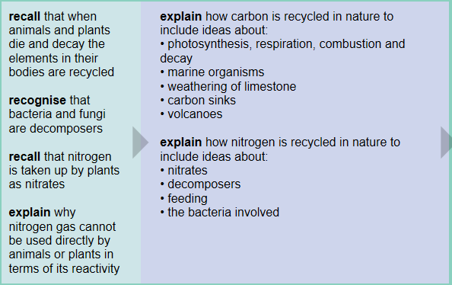
Key Information
Carbon and Nitrogen are elements that are recycled in nature.

They are ‘recycled’ by plants, animals and microorganisms.

Revision Ideas
- Draw the carbon cycle. Write photosynthesis, respiration, burning, death and eating on post-it notes, and test yourself by trying to remember where to put them.
- Draw the nitrogen cycle. Cover ¼ at a time, and try and remember what’s missing.

QWC Question (6 marks)
When answering a QWC question remember the following points: Use correct science vocabulary, organise ideas, avoid using “it”, and write in full sentences. You also need to try and keep you answer relevant to the question. A good way to do all this is to write out important key vocabulary and then use them to structure your answer. Underlining them will help you keep track and highlight to the examiner your good use of key terms,
Question – This question is about the carbon and nitrogen cycles.
In a stable community, the removal of materials is balanced by the return of materials. Carbon and nitrogen are both recycled in the environment. Describe how they are recycled, and explain the factors that affect them. (6marks)
Important words list
Photosynthesis
Respiration
Decomposition
Microorganisms
Feeding
Excretion
Decay
Absorb
Nitrates

B2d: Interdependence
Grade E Grade C Grade A
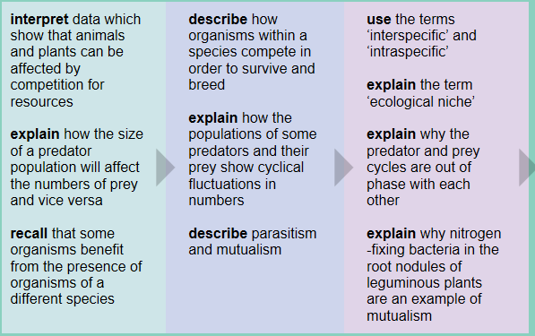
Key Information
All organisms depend on other organisms.
Sometimes they compete for resources, sometimes they help each other, sometimes they take advantage of each other, and sometimes they hunt each other!
You need to be able to explain all these relationships!
Revision Ideas
- For each heading on pages 30-31 of your revision guide, think of an example, and use as many scientific terms as you can to explain what’s happening.
- Make a card sort of the key terms.

QWC Question (6 marks)
When answering a QWC question remember the following points: Use correct science vocabulary, organise ideas, avoid using “it”, and write in full sentences. You also need to try and keep you answer relevant to the question. A good way to do all this is to write out important key vocabulary and then use them to structure your answer. Underlining them will help you keep track and highlight to the examiner your good use of key terms,
Question – This question is about relationships between organisms.
The size and distribution of a population of organisms will change over time. Competition between different species causes changes in numbers. Grass and daisies all compete for the same resources. Explain what grass and daisies compete for, and how it affects them. (6marks)
Important words list
Population
Competition
Resources
Sunlight
Water
Space
Minerals
Adapted
Survive
Produce
B2e: Adaptations
Grade E Grade C Grade A
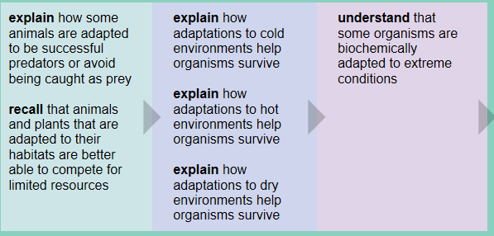
Key Information
All organisms are adapted to their environment – they have ‘special features’ that help them survive.
Organisms that live in hot and dry climates have very different adaptations to those in cold climates.
Predators and prey also have specific adaptations.

Revision Ideas
- Draw/find a picture of a typical ‘predator’ and its ‘prey’ and label all the features that most predators and prey have.
- Find loads of pictures off the internet of organisms that live in hot climates, and those that live in cold climates, and identify their adaptations.

QWC Question (6 marks)
When answering a QWC question remember the following points: Use correct science vocabulary, organise ideas, avoid using “it”, and write in full sentences. You also need to try and keep you answer relevant to the question. A good way to do all this is to write out important key vocabulary and then use them to structure your answer. Underlining them will help you keep track and highlight to the examiner your good use of key terms,
Question – This question is about adaptations of organisms.
Adaptations are special features or behaviours that make an organism well suited to its environment. Describe an organism that lives in a cold environment, and explain how its adaptations help it survive. (6marks)
Important words list
Insulated
Surface area
Volume
Hibernate
Migrate
Fat
Fur
Large feet
B2f: Natural selection
Grade E Grade C Grade A
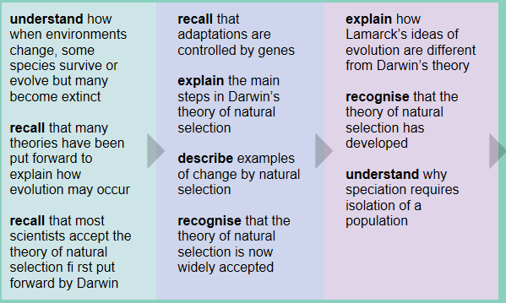
Key Information
This topic is about evolution: how the best adapted organisms survive and reproduce.
Variation leads to competition, which leads to the better adapted surviving, This means that the genes of the best adapted organisms are more likely to be passed on.
Revision Ideas
- Draw a cartoon strip showing how horses could have developed into giraffes – making sure you include ALL the key points above.
- Try and explain to your mum/dad/sister/brother/dog why doctors always make you finish a course of antibiotics.

QWC Question (6 marks)
When answering a QWC question remember the following points: Use correct science vocabulary, organise ideas, avoid using “it”, and write in full sentences. You also need to try and keep you answer relevant to the question. A good way to do all this is to write out important key vocabulary and then use them to structure your answer. Underlining them will help you keep track and highlight to the examiner your good use of key terms,
Question – This question is about evolution by natural selection.
Evolution is the specialisation of a population over many generations to become better adapted to its environment. In an environment where the trees had mostly light-coloured bark, explain how a population of some dark and some light coloured moths might end up being all light coloured. (6marks)
Important words list
Variation
Competition
Better adapted
Survive
Survival of the fittest
Genes
Offspring

B2g: Population and Pollution
Grade E Grade C Grade A
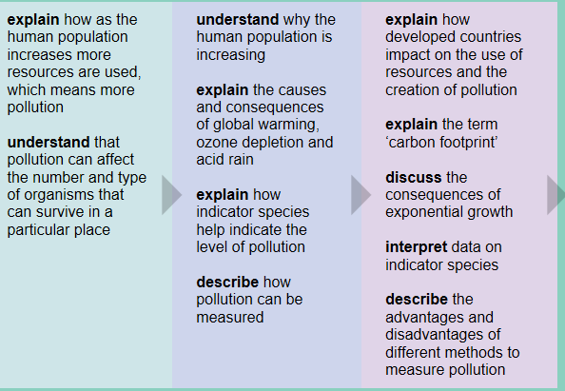
Key Information
The human population is increasing at a rapid rate. This is causing problems such as pollution, damage to the ozone layer, acid rain and global warming.
We can use living organisms as indicator species.
Revision Ideas
- Draw a picture of planet Earth, and label all around it the ways that increasing populations are causing damage (use your revision guide to make sure you use the correct scientific terms.
- Explain to someone (or write down) how you can use lichens to tell if the air is polluted.
QWC Question (6 marks)
When answering a QWC question remember the following points: Use correct science vocabulary, organise ideas, avoid using “it”, and write in full sentences. You also need to try and keep you answer relevant to the question. A good way to do all this is to write out important key vocabulary and then use them to structure your answer. Underlining them will help you keep track and highlight to the examiner your good use of key terms,
Question – This question is about indicator species.
Some organisms are adapted to live in ‘clean’ environments, while others live in more polluted areas. For example, some varieties of lichens are able to survive when high levels of sulphur dioxide are present in the air. Describe what an indicator species is, and explain how we can use lichens to indicate whether the air is polluted or not. (6marks)
Important words list
Lichen
Survival
Adapted
Sensitive
Resist
Toxic
High levels
Sulfur dioxide
Indicator

B2h: Sustainability
Grade E Grade C Grade A
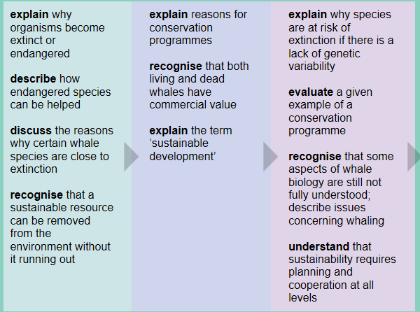
Key Information
A sustainable resource is one that can be used and replaced so that it isn’t used up completely. Some species are endangered, and if they are not protected, will become extinct.
There are different conservation programmes which can protect endangered organisms.
Revision Ideas
- Search on the internet for 5 endangered species. Try and find out why they are endangered – match up reasons with ones in the revision guide.
- Make revision cards about whales – why are they endangered? How can they be protected?
QWC Question (6 marks)
When answering a QWC question remember the following points: Use correct science vocabulary, organise ideas, avoid using “it”, and write in full sentences. You also need to try and keep you answer relevant to the question. A good way to do all this is to write out important key vocabulary and then use them to structure your answer. Underlining them will help you keep track and highlight to the examiner your good use of key terms,
Question – This question is about sustainability.
Endangered species are those that are in danger of becoming extinct unless something is done to prevent it. Discuss what can endanger the survival or a plant or animal, and describe some methods in which they can be protected. (6marks)
Important words list
Climate
Habitat destruction
Hunting
Competition
Pollution
Education
Conserving
Laws
Seed banks

