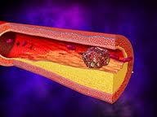**B1 Module Summary**

**Heart disease**

Diet and smoking, their effects on blood pressure. How cholesterol can cause problems.

Coronary heart disease, what is a thrombosis and how is it caused?

**Fitness and health**

Blood pressure – how to measure and control it. Ways to maintain a healthy blood pressure.

Information about protein.

How much we should eat. EAR = estimated average requirement.

Calculating you EAR using; EAR (g) = body mass (kg) x 0.6

Calculating your body mass index (BMI) using the formula;

BMI = mass (kg)

height (m2)

Human health and diet.

What are the components of a healthy diet?

Why we eat food, and the importance of a balanced diet.

What food is made of;

Glucose starch

Amino acids protein

Glycerol +fatty acids fat

How food is stored in our bodies.

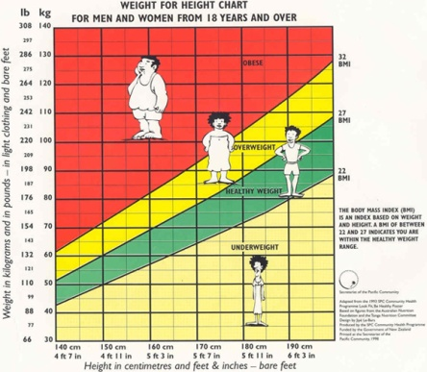

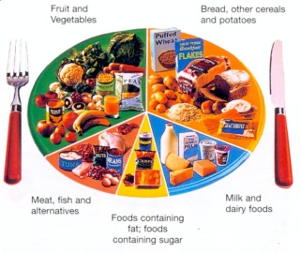

Staying healthy.

Pathogens cause disease. There are 4 types of pathogen;

Fungi - causes Athlete’s foot

Bacteria - causes Cholera

Viruses - causes Flu

Protozoa - causes Malaria

Vectors spread disease.

Vectors include flies and mosquitoes.

Malaria is caused by a protozoan called *Plasmodium* which is carried by female mosquitoes.

How to help the body fight disease.

Cancer is a result of cells dividing out of control.

Tumours can form from these cells.

Benign tumours, are slow to divide and harmless.

Malignant tumours are cancerous, and can spread throughout the body.

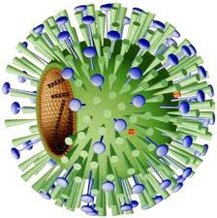

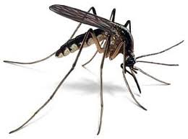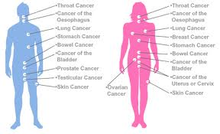

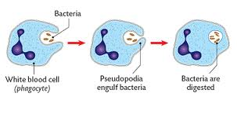

Fighting sickness,the immune system.

White blood cells destroy pathogens that enter our body.

They can;

* Surround and engulf them.
* Make antibodies that stick them together.

Immunity.

Immunity that involves antibodies is called active immunity. The white blood cells make

antibodies in response to antigens on the pathogens surface. If your body is attacked by the

same pathogen again in the future, the white blood cells ‘recognise’ it and your body responds

more quickly to produce the correct antibodies.

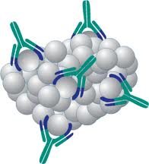

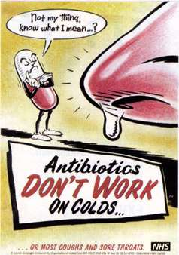

Vaccination.

Vaccination starts with an injection of a

harmless pathogen into the body.

The antigens on the pathogens surface

trigger an immune response and WBCs

produce antibodies.

Memory cells are also made in response

to the antigen.

Memory cells, produced in this way, remain in the body for a long time, and if the pathogen enters the body again sometime in the future, a faster immune response will be triggered off.

Antibiotics

Antibiotics are drugs used to treat bacterial or fungal infections.

They DO NOT work on viruses, you need an anti-viral drug to treat these types of infections.

Antibiotics slow down a pathogen’s development.

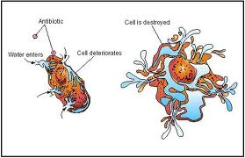

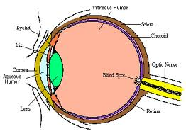

The nervous system.

Understanding vision.....

Learn the labels on the diagram of the eye.

Vision in one eye – monocular vision.

Vision in two eyes – binocular vision.

Long and short sight problems can be corrected by getting glasses or contact lenses from the optician, using a concave lens for short-sight and a convex lens for long-sight.

Reflex reactions include;

* Pupil dilating/contracting
* Knee jerk reaction
* Taking hand away from hot flame

Information is carried around the body as nerve impulses (electrical signals) in nerve cells called neurones.

The nervous system has 2 parts;

**Central nervous system** (CNS) = brain and spinal cord.

**Peripheral nervous system** (PNS) = nerves to and from the brain and spinal cord

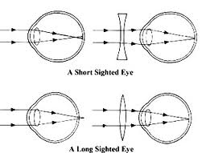

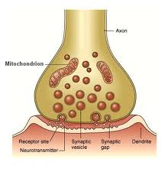

Neurones are long (up to 2m), have branched endings (dendrites), and are insulated with fat to stop electrical impulses crossing over.

Between each neurone is a gap, called a **synapse**. Signals have to cross this gap to send the message from one neurone to another.

A nerve impulse triggers the release of transmitter substances (e.g. **acetylcholine**) which diffuses across the synapse.

A spinal reflex has a series of stages;

Stiumulus

Receptor

Sensory neurone

Relay neurone

Motor neurone

Effector

Response

**Drugs and You.**

Some drugs are useful, others can be harmful. Learn which is which!

There are different ‘types’ of drugs;

* Depressants
* Hallucinogens
* Painkillers
* Performance enhancers
* Stimulants

A person can become addicted to a drug, and can develop a tolerance for it.

When they want to give up the drug they may suffer withdrawal symptoms.

Learn the different types of drugs, which class they belong to and what the penalty is for using, possessing or supplying each type.

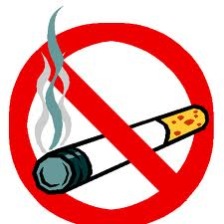

What is in tobacco smoke?

* Carbon monoxide
* Nicotine
* Tar
* Particulates

Epithelial cells in the breathing system are lined with tiny hairs (cilia), cigarette smoke stops these from moving and makes goblet cells produce more mucus.

Dust and particulates accumulate in the mucus and cause ‘smokers cough’

Smoking also causes lung cancer and other diseases, and is responsible for many deaths in the UK each year.

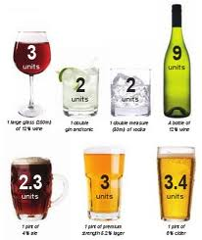

Alcohol.

The alcohol content of a drink is measured in **units.**

One unit is equivalent to 10ml of pure alcohol.

**Effects of alcohol on the liver.**

The liver breaks down (oxidises) harmful substances, like drugs and alcohol. Enzymes in the liver break down these harmful substances into less harmful ones, like carbon dioxide and water.

Alcohol and its toxic breakdown products damage the liver, forming scar tissue. This is called alcoholic **cirrhosis**.

**Homeostasis**

Maintaining a constant internal environment is called **homeostasis**. The nervous system and **hormones** are responsible for this.

**Body temperature -** is controlled to maintain the temperature at which enzymes work best (37°C)

**Hormones**

**Blood sugar level -** This is controlled to provide cells with a constant supply of energy. The blood sugar level is controlled by the release and storage of glucose, which is in turn controlled by a hormone called **insulin**.

**Diabetes** is a disorder in which the blood glucose levels remain too high. It can be treated by carefully maintaining a certain diet or injecting insulin. The extra insulin allows the glucose to be taken up by the liver and other tissues, so cells get the glucose they need and blood sugar levels stay normal.

**D** - Hair muscles relax. Hairs lie

flat so heat can escape.

**E** - Sweat secreted by sweat glands.

Cools skin by evaporation.

**F** - Blood flow in capillaries

increases.

**A** - Hair muscles pull hais

on end.

**B** - Erect hairs trap air.

**C** - Blood flow in capillaries

decreases.

| **Diagram shows cross section of skin when cold, with erect hairs (B) caused by tense hair muscles (A), and reduced blood flow to capillaries (C) Too cold** | **Diagram shows a cross section of skin when hot. Hair muscles relax (D) causing hairs to lie flat so that heat can escape. Sweat is secreted (E) from the sweat glands. Blood flow in the capillaries is increased (F)Too hot** |
| --- | --- |
|  |  |

**Plant growth and ripening.**

Plants respond to light and gravity. They use **plant hormones** to control different processes.

* Growth of shoots towards light.
* Growth of roots downwards.
* Growth of flowers.
* Ripening of fruit.

**Plants are sensitive**.

They respond to different **stimuli**.

A negative response = plant grows away from stimulus.

A positive response = plant grows towards stimulus.

When a plant responds to light it is called **phototropism**.

Shoots grow towards light this is positive phototropism.

Roots grow away from light this is called negative phototropism.

When a plant responds to gravity it is called **geotropism**.

Shoots grow away from the pull of gravity this is negative geotropism.

Shoots grow with the pull of gravity this is positive geotropism.

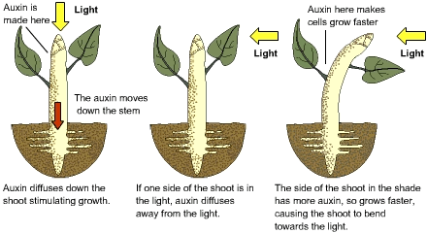

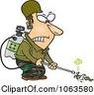

**Plant hormones** can be used to regulate plant **growth**, by farmers and growers.

They can be used as weedkillers.

**Auxin** is used to accelerate plant growth so they die off.

New plants can be grown from cuttings.

If the cutting is dipped into a hormone-based rooting powder (**synthetic auxin**) it stimulates root growth.

**Gibberellic acid** is a hormone used to stimulate seed **germination**.

**Variation and inheritance.**

The **nucleus** of a cell contains [*chromosomes*](http://www.bbc.co.uk/schools/gcsebitesize/science/ocr_gateway/ourselves/6_gene_control1.shtml) that carry genetic information. Most body cells have the same number of chromosomes, but this varies between species. Human body cells, for example, each have 23 matching pairs of chromosomes.

Chromosomes are made from long, coiled molecules of [*DNA*](http://www.bbc.co.uk/schools/gcsebitesize/science/ocr_gateway/ourselves/6_gene_control1.shtml). A [*gene*](http://www.bbc.co.uk/schools/gcsebitesize/science/ocr_gateway/ourselves/6_gene_control1.shtml)is a shorter region of DNA that carries the genetic code for a particular characteristic or cell activity.

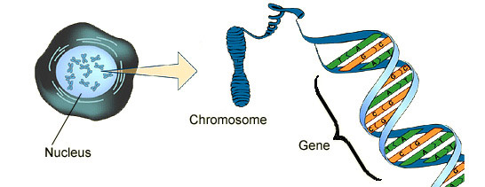

Some characteristics are **dominant**, and some are **recessive**. You can tell what a characteristic is like by studying the results of breeding experiments.

Genetic variation can be caused by:

* the formation of gametes - sex cells
* fertilisation - the joining of gametes
* mutation

In humans and other mammals, gender is controlled by a pair of sex chromosomes. Females have two X chromosomes, XX. Males have one X and one Y chromosome, XY.

A **mutation** is a change to the genetic code in a gene. Mutations can happen spontaneously. They can also be caused by radiation and certain chemicals. Mutations may be beneficial, but most are harmful.

Inherited disorders such as red-green colour blindness, sickle cell anaemia and cystic fibrosis are caused by faulty genes.

**Alleles** are different versions of the same gene. An allele can be dominant or recessive. Individuals, meanwhile, can be homozygous or heterozygous:

* individuals who are **homozygous** for a certain gene carry two copies of the **same allele**
* individuals who are **heterozygous** for a certain gene carry two **different alleles**

A recessive characteristic will only be shown if an individual is homozygous for the recessive allele. A dominant characteristic will be shown even if an individual is heterozygous for the dominant allele.